
Year 11 ATAR Chemistry
Practical Assessment – Validation Test
Temperature & Rate of Reaction

NAME: ________________________ TEACHER: ________________________
MARKS: _____ / 16
Answer each question in the space provided.
- Using collision theory, explain why the rate of a chemical reaction increases when the reactants are heated. (3 marks)

- Draw an energy profile diagram that shows an exothermic reaction with an activation energy value of 75 kJ and a change in enthalpy of -36 kJ. (4 marks)

- Identify three variables that needed to be controlled in this experiment. (3 marks)
- The chemical reaction that occurs between hydrochloric acid and sodium thiosulfate is shown in the following ionic equation:

S₂O₃²⁻_{(aq)} + 2H⁺_{(aq)} S_{(s)} + SO_{2(aq)} + H₂O_{(l)}

Explain the observations made during the chemical reaction. (2 marks)

- Explain what is occurring in the following diagram. (2 marks)

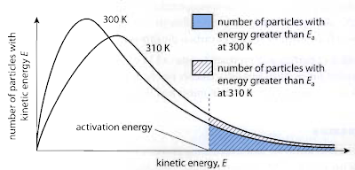

- What are two sources of error that are present in this experiment? (2 marks)

End of Validation Test

